

De La Salle University- Manila
Gokongwei College of Engineering

Lab Activity Number : 1, 2, & 3
Lab Activity Title : HTML Basics, Web Graphics, and Frame-based Portfolio Layouts

Date Performed : 1/14/26
Date Submitted : 1/21/26

Instructor : Melvin K. Cabatuan, Ph.D.

Name of Student : Ezekiel John R. Libao
Student ID : 12312126
Subject / Section : LBYCPG3

Remarks:

_______________________________________________________________
_______________________________________________________________

Introduction:
This lab report is a combination of 3 lab activities. All 3 lab activities focuses on the basics of HTML, which also includes web graphics and creating a frame-based portfolio. Lab activity 1 focuses on the basics of HTML, the syntax, structure, headings and lists. Lab activity 2 focuses on adding visual elements to the web page by introducing images and background designs. Lab activity 3 is a bit challenging compared to the previous as this activity requires us to create a web-based personal portfolio. We utilized HTML Frames/iFrames for the layout of the webpage, and added CSS for better design and styling. HTML Forms was also used to allow the user to input text.

Objectives:
Lab activity 1:
- Start and familiarize the VS Code IDE
- Start and quit the web browser
- Draw, label and identify the basic parts of the VS Code
- List down the functions of the parts of the VS Code
- Enter and use HTML, HEAD, TITLE and body tags correctly
- Create a simple web page
- Save the HTML file
- View the HTML file in the web browser
- Identify and correct simple HTML programming errors
Lab activity 2:
- Change the font size, color and format of text of a web page
- Describe what is homepage
- Create a home page
- Explain the difference between the two (2) classes of web images
- Differentiate the various types of web images
- Insert a background image
- Insert a horizontal rule image Discussion:

Lab activity 3:
- Apply HTML frames to structure a website layout.
- Use HTML forms to collect user input or showcase interactive elements.
- Develop a complete menu-driven personal portfolio website using HTML frames.

Lab activity 1 exercise 1 Problem:
1. In your VS Code, type <HTML> and then press the Enter Key.
2. Type <HEAD> and then press the Enter key
3. Type <TITLE> Computer Technician </TITLE> and then press the Enter key
4. Type </HEAD> and then press the Enter key.
5. Type <BODY> and then press the Enter key twice.
6. Type </BODY> and then press the Enter key.
7. Type </HTML> as the tag.

To create the Web page heading:
8. Click the blank line below <BODY> type <H1> What is a Computer Technician ?</H1> and then press the enter key.

To enter text in paragraph format:

9. With the insertion point on line 7, type <P> A computer technician is a person who repairs and maintains computers and servers. The technician’s responsibilities may extend to include building or configuring new hardware, installing and updating software packages, and creating and maintaining computer networks. Computer repair technicians work in a variety of settings, encompassing both the public and private sectors. Because of the relative newness of the profession, institutions offer certificate and degree programs designed to prepare new technicians, but computer repairs are frequently performed by experienced and certified technicians who have little formal training in the field </P> and then press the Enter key

Creating a Bulleted List

10. With the Insertion Point at line 11, type <H2> What steps do I need to follow to become a computer technician?</H2> and then press the Enter key
11. Type <UL> and then press the Enter key
12. Type <LI>Learn about computers </LI> and then press the Enter key
13. Type <LI>Gain experience</LI> and then press the Enter key
14. Type <LI>Get formal computer training </LI> and then press the Enter key
15. Type <LI>Obtain certifications </LI> and then press the Enter key
16. Type the </UL> tag

Saving the HTML File
17. Save this as exercisel-webpage.html on your folder in the hard disk.

Using the Web Browser to View the HTML File
18. Click the Start button on the taskbar and then point to Programs on the Start Menu. Point to the Internet Explorer or your web browser on the Programs submenu.
19. Now, open your HTML file. Your screen should at least resemble Figure 4. You've just created your first web page.

Lab activity 1 exercise 1 Procedure:
- Open Visual Studio Code (VS Code) and create a new file.

- Initialize the document structure by typing the opening <HTML> and <HEAD> tags.

- Inside the head section, add the title <TITLE>Computer Technician</TITLE>.

- Close the head with </HEAD> and open the body section with <BODY> .

- Create a main heading using the <H1> tag with the text "What is a Computer Technician?".

- Insert a descriptive paragraph about computer technicians or just copy and paste the given using the <P> and </P> tags.

- Add a sub-heading using <H2> for the steps required to become a technician.

- Create an unordered list using the <UL> tag. Add four list items (<LI>) for: learning about computers, gaining experience, formal training, and certifications. Close the list with </UL> .
- Close the body and html tags.

- Save the file as exer1_webpage.htm and open it via a web browser to verify the output.

Lab activity 1 exercise 1 code:

<!DOCTYPE html>
<html>
<head>
<title>Computer Technician</title>
</head>

<body>

<h1>What is a Computer Technician ?</h1>

<p>A computer technician is a person who repairs and maintains computers and servers. The technician’s responsibilities may extend to include building or configuring new hardware, installing and updating software packages, and creating and maintaining computer networks. Computer repair technicians work in a variety of settings, encompassing both the public and private sectors. Because of the relative newness of the profession, institutions offer certificate and degree programs designed to prepare new technicians, but computer repairs are frequently performed by experienced and certified technicians who have little formal training in the field</p>

<h2>What steps do I need to follow to become a computer technician?</h2>

<ul>
<li>Learn about computers</li>
<li>Gain experience</li>
<li>Get formal computer training</li>
<li>Obtain certifications</li>
</ul>

</body>
</html>

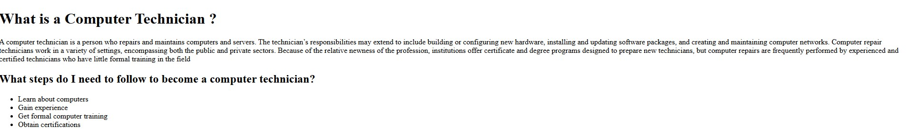Lab activity 1 exercise 1 screenshot:

Lab activity 1 exercise 1 Experimental Observation:
In the first exercise of the laboratory activity, I observed the basic syntax of HTML. To make the text the largest on the page, the <H1> tag should be used. In order to put text or paragraphs, the <P> tag is required. This exercise also requires us to list down some texts. The <UL> tag was used to list them down one by one. The browser then automatically applied a solid circle to the bullets by default. The output displayed as what the problem intends.

Lab activity 1 exercise1a Problem:
Use the same HTML used in the first exercise, then add modifications like changing heading sizes and use a different bullet style.

Lab activity 1 exercise1a Procedure:
- Open the previous file exer1_webpage.html in VS Code.

- Create another file and name it as exer1a_webpage.html in VSCode.

- Locate the main heading tag <H1> and change it to a smaller size, specifically <H3>, to observe the difference in text rendering.

- Locate the sub-heading <H2> and change it to <H4> to maintain hierarchy while reducing size.

- Modify the unordered list tag <UL> by adding the type attribute type="square" to change the bullet style from the default disc to squares.

- Open the new file in the web browser and compare the visual differences with the first file.

- Close the browser and editor properly.

Lab activity 1 exercise1a Code:

<!DOCTYPE html>
<html>
<head>
<title>Computer Technician</title>
</head>

<body>

<h3>What is a Computer Technician ?</h3>

<p>A computer technician is a person who repairs and maintains computers and servers. The technician’s responsibilities may extend to include building or configuring new hardware, installing and updating software packages, and creating and maintaining computer networks. Computer repair technicians work in a variety of settings, encompassing both the public and private sectors. Because of the relative newness of the profession, institutions offer certificate and degree programs designed to prepare new technicians, but computer repairs are frequently performed by experienced and certified technicians who have little formal training in the field</p>

<h4>What steps do I need to follow to become a computer technician?</h4>

<ul type="square">
<li>Learn about computers</li>
<li>Gain experience</li>
<li>Get formal computer training</li>
<li>Obtain certifications</li>
</ul>

</body>
</html>

Lab activity 1 exercise1a Screenshot:
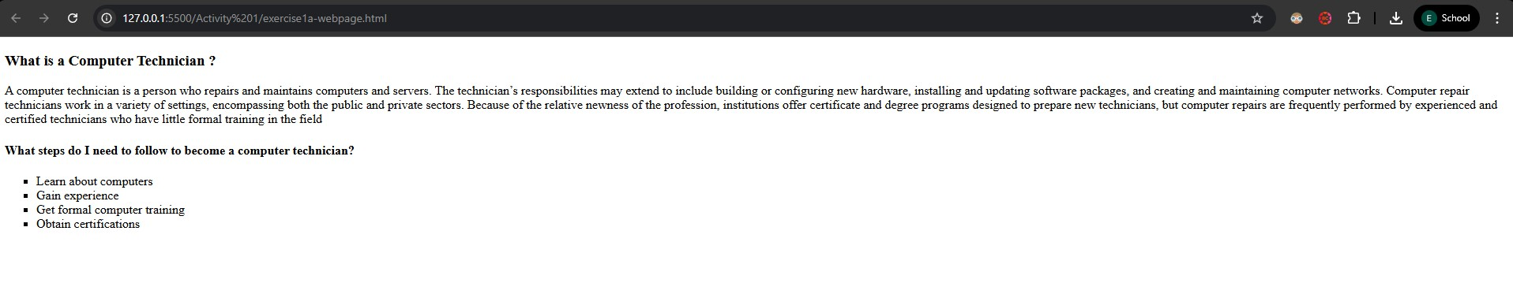

Lab activity 1 exercise 1a Experimental Observation #2:
In this second exercise, when I changed the <H1> to <H3>, I observed that the font size got smaller. For the sub-heading which I originally used <H2>, I used <H4> which is smaller than the previous one, and also smaller than <H3>. Another observation is changing the bullet style. For this, I added “type =”square”” inside the <ul> tag. This made the default circle bullets into a square.

Lab activity 2 Problem:
Modify the code from the previous lab activity to include background image, font color and a horizontal bar to separate the sections.

Lab activity 2 Procedure:

1. Open MS Paint.
2. Create an image that will serve as your background for your homepage.
3. If you like, you can copy any image file available in Windows and then paste it in Paint.
4. Save this file as background.jpg in your project folder
Creating a Home Page
5. Open VS Code or Notepad++.

6. Enter initial HTML tags. Type <HTML> and then press the Enter key. Type
<HEAD> and then press the Enter key

7. Type <TITLE>DLSU </TITLE> and then press the Enter key
8. Type </HEAD> and then press the Enter key
9. Type <BODY> and then press the Enter key
10. Type </BODY> and then press the Enter key
11. Type </HTML> and then press the Enter key
12. Position the insertion point on the blank line between the <BODY> and
</BODY>
13. We know that <H1> tag assigns the largest possible size to a heading and the attribute ALIGN = "CENTER" will center the heading. We will enhance our home page with the <FONT> and </FONT> tags. Click line 6 between the
<BODY> and the </BODY> tags, type <H1 ALIGN = "CENTER"><FONT COLOR = "#000066"> Computer Technician
</FONT></H1> and then press the Enter key.
14. With the insertion point in line 7, type <P> In a nutshell, computer technicians perform installation & maintenance or solve problems that people have with their computers. Just as there are different types of computers and different levels of computer systems and networks, there are also several different types of computer specialist. A partial list of some of the job designations in this growing field includes the following:
</P> as the first paragraph of the body.
15. Press the ENTER key.
16. After the first paragraph, type <H2> What does a computer technician do?
</H2> and then press the Enter key.
17. Now, we are to add a bulleted list of information. Recall that in exer1_webpage.htm, we performed this operation without changing the bullet type available, which is the disc. We will now use the bullet type square for this activity. Create a bulleted list for the following elements:

 Desktop Support Specialist
 Network Administrator
 Systems Administrator
 Computer Forensics Specialist
 Help Desk Technician
 Customer Support Analyst
 Internet Professional
18. Now, type <H2>Our Services </H2> next and then press the enter key. This would be our next subheading.
19. Create another list, using the bullet square, with the following elements:
 Computer Troubleshooting and Repair
 Software Package Installation
 Network Maintenance and Troubleshooting
 Web Page Development and Maintenance
 Printing
We've just created the first part of our web page.
20. Now, we are to insert background and horizontal rule image for our web page. To add a background image. First, position the insertion point immediately to the Y in the <BODY> tag and then press the space bar. Type BACKGROUND = "directory and the filename of the image". In this case, use the image file, background.jpg you've created earlier.
21. We have just added an image background to our web page. We are now ready to create a horizontal rule image. But we first have to create the horizontal bar. Open your MS Paint and then using the box object, create a rectangular image filled with color blue. Save this at your project folder with filename bluebar.jpg. We will use this as our horizontal rule image.
22. Going back to VS Code, point the insertion point to the right of the </H1> and then press the Enter key. Type <CENTER> <IMG SRC = "bluebar.jpg" HEIGHT = 5 WIDTH = 500> </CENTER> as the tag.
This line defines our horizontal rule. It tells that the horizontal rule should be place at center and with height and weight dimensions specified.

23. We are to copy this horizontal rule image at the bottom of our 1st bulleted list. Highlight the text <CENTER> <IMG SRC = "bluebar.jpg" HEIGHT = 5 WIDTH = 500> </CENTER> and then click the EDIT menu then Copy. Now, position the insertion point at the end of our 1st unordered list and then click the EDIT menu again and then click PASTE. We have now two (2) horizontal rule images.
24. Save this exercise as exer2_webpage.htm. View this file on the web browser. Your screen should at least resemble figure 3.2.

Lab activity 2 Code:

<!DOCTYPE html>
<html>
<head>
<title>DLSU</title>
</head>

<body background="background.jpg">

<h1 align="center"><font color="#000066">Computer Technician</font></h1>

<center><img src="bluebar.jpg" height="5" width="500"></center>

<p>In a nutshell, computer technicians perform installation & maintenance or solve problems that people have with their computers. Just as there are different types of computers and different levels of computer systems and networks, there are also several different types of computer specialist. A partial list of some of the job designations in this growing field includes the following :</p>

<h2>What does a computer technician do?</h2>

<ul type="square">
<li>Desktop Support Specialist</li>
<li>Network Administrator</li>
<li>Systems Administrator</li>
<li>Computer Forensics Specialist</li>
<li>Help Desk Technician</li>
<li>Customer Support Analyst</li>
<li>Internet Professional</li>
</ul>

<center><img src="bluebar.jpg" height="5" width="500"></center>

<h2>Our Services</h2>

<ul type="square">
<li>Computer Troubleshooting and Repair</li>
<li>Software Package Installation</li>
<li>Network Maintenance and Troubleshooting</li>
<li>Web Page Development and Maintenance</li>
<li>Printing</li>
</ul>

</body>
</html>

Lab activity 2 Screenshot:


Lab activity 2 Experimental Observation:
In this activity, I observed that images help improve the design of web pages. However, it is important to use the correct file path or to put the image in the correct folder as the image will not load properly otherwise. The image separator gives more flexibility in design than using the <hr> tag.

Lab activity 3 Problem:
Develop a complete Personal Portfolio website structured with HTML Frames. The site must include a Header, a Navigation Menu, and content pages (Home, About, Experience, etc.), and must feature an interactive Contact Form

Lab activity 3 Procedure:
- Think of a design layout using iframes.
- There should be a top header, a menu section, and a main content area.
- Create index.html which is the container of the iFrames and CSS which will hold the layout.
- The header.html will contain the profile picture and name.
- The menu.html will contain the navigation links to the content pages like home, about, experience, etc.
- It is important to set “targets=”mainContent” so that it will open the correct frame.
- CSS was used for this lab activity to provide an aesthetic appeal to the web page.
- The HTML forms was created in the home tab, in the “Get In Touch” section using the <form> tag. This includes text fields for the user to input their names, email, subject, and message. Javascript was used to handle the submission visually.

Lab activity 3 Codes:

about.html:
<!DOCTYPE html>
<html lang="en">

<head>
<meta charset="UTF-8">
<meta name="viewport" content="width=device-width, initial-scale=1.0">
<title>About Me</title>
<style>
body {
margin: 0;
padding: 0;
background: linear-gradient(135deg, #f5f7fa 0%, #c3cfe2 100%);
font-family: 'Segoe UI', Tahoma, Geneva, Verdana, sans-serif;
height: 100vh;
overflow-y: auto;
}

.about-container {
max-width: 900px;
margin: 0 auto;
padding: 50px 30px;
}

.page-title {
color: #1e3c72;
font-size: 2.8em;
margin-bottom: 40px;
text-align: center;
font-weight: 700;
}

.about-card {
background: white;
border-radius: 15px;
padding: 50px;
box-shadow: 0 10px 30px rgba(0, 0, 0, 0.1);
margin-bottom: 30px;
}

.profile-section {
margin-bottom: 40px;
text-align: center;
}

.profile-section h2 {
color: #1e3c72;
font-size: 2.5em;
margin-bottom: 10px;
}

.profile-section .role {
color: #667eea;
font-size: 1.4em;
margin-bottom: 30px;
font-weight: 600;
}

.bio {
color: #555;
font-size: 1.1em;
line-height: 1.8;
margin-bottom: 30px;
}

.interests-section h3 {
color: #1e3c72;
font-size: 1.8em;
margin-bottom: 20px;
display: flex;
align-items: center;
gap: 10px;
}

.interests-list {
display: grid;
grid-template-columns: repeat(auto-fit, minmax(200px, 1fr));
gap: 15px;
margin-top: 20px;
}

.interest-item {
background: linear-gradient(135deg, #667eea15 0%, #764ba215 100%);
padding: 20px;
border-radius: 10px;
border-left: 4px solid #667eea;
color: #333;
font-size: 1.05em;
transition: transform 0.3s ease;
}

.interest-item:hover {
transform: translateX(5px);
}

.interest-icon {
font-size: 1.5em;
margin-right: 10px;
}
</style>
</head>

<body>
<div class="about-container">
<h1 class="page-title">About Me</h1>

<div class="about-card">
<div class="profile-section">
<h2>Ezekiel John R. Libao</h2>
<p class="role">Computer Engineering Student</p>
</div>

<div class="bio">
<p>I am an undergraduate Computer Engineering student at De La Salle University. I am very interested in
both the software and hardware aspects of computers, exploring how systems work from the ground
up—from circuit design and digital logic to software development and programming.</p>
<p>Through my studies, I've gained hands-on experience in both hardware and software development. On the
hardware side, I work with digital systems, microprocessors, and embedded systems. On the software
side, I develop practical applications and interactive projects. I'm passionate about understanding
the complete computing stack and how hardware and software work together to create powerful systems.
</p>
</div>

<div class="interests-section">
<h3>💡 Interests & Hobbies</h3>
<div class="interests-list">
<div class="interest-item">
<span class="interest-icon">💻</span>
Software Development
</div>
<div class="interest-item">
<span class="interest-icon">⚙️</span>
Computer Hardware
</div>
<div class="interest-item">
<span class="interest-icon">🔌</span>
Embedded Systems
</div>
<div class="interest-item">
<span class="interest-icon">🔧</span>
Problem Solving
</div>
<div class="interest-item">
<span class="interest-icon">📚</span>
Continuous Learning
</div>
<div class="interest-item">
<span class="interest-icon">🚀</span>
Innovation
</div>
</div>
</div>
</div>
</div>
</body>

</html>

Education.html:
<!DOCTYPE html>
<html lang="en">

<head>
<meta charset="UTF-8">
<meta name="viewport" content="width=device-width, initial-scale=1.0">
<title>Education</title>
<style>
body {
margin: 0;
padding: 0;
background: linear-gradient(135deg, #f5f7fa 0%, #c3cfe2 100%);
font-family: 'Segoe UI', Tahoma, Geneva, Verdana, sans-serif;
height: 100vh;
overflow-y: auto;
}

.education-container {
max-width: 900px;
margin: 0 auto;
padding: 50px 30px;
}

.page-title {
color: #1e3c72;
font-size: 2.8em;
margin-bottom: 20px;
text-align: center;
font-weight: 700;
}

.page-subtitle {
text-align: center;
color: #666;
font-size: 1.2em;
margin-bottom: 50px;
}

.education-card {
background: white;
border-radius: 15px;
padding: 50px;
box-shadow: 0 10px 30px rgba(0, 0, 0, 0.1);
margin-bottom: 30px;
}

.school-header {
display: flex;
align-items: center;
gap: 30px;
margin-bottom: 30px;
padding-bottom: 30px;
border-bottom: 2px solid #f0f0f0;
flex-wrap: wrap;
}

.school-logo {
width: 120px;
height: 120px;
background: linear-gradient(135deg, #667eea 0%, #764ba2 100%);
border-radius: 15px;
display: flex;
align-items: center;
justify-content: center;
font-size: 3.5em;
color: white;
flex-shrink: 0;
box-shadow: 0 8px 20px rgba(102, 126, 234, 0.3);
}

.school-info {
flex: 1;
}

.school-name {
color: #1e3c72;
font-size: 2.2em;
font-weight: 700;
margin-bottom: 10px;
}

.degree {
color: #667eea;
font-size: 1.4em;
font-weight: 600;
margin-bottom: 10px;
}

.status {
color: #28a745;
font-size: 1.1em;
font-weight: 600;
background: #28a74515;
padding: 8px 16px;
border-radius: 20px;
display: inline-block;
border: 1px solid #28a74530;
}

.details-section {
margin-top: 30px;
}

.details-section h3 {
color: #1e3c72;
font-size: 1.6em;
margin-bottom: 20px;
display: flex;
align-items: center;
gap: 10px;
}

.details-section p {
color: #555;
font-size: 1.1em;
line-height: 1.8;
margin-bottom: 15px;
}

.coursework {
display: grid;
grid-template-columns: repeat(2, 1fr);
gap: 15px;
margin-top: 20px;
}

.course-item {
background: linear-gradient(135deg, #667eea08 0%, #764ba208 100%);
padding: 15px 20px;
border-radius: 10px;
border-left: 4px solid #667eea;
color: #333;
font-size: 1.05em;
}

.achievements {
background: linear-gradient(135deg, #fff9e6 0%, #ffe6cc 100%);
padding: 25px;
border-radius: 10px;
border-left: 4px solid #ffa500;
margin-top: 30px;
}

.achievements h4 {
color: #cc8400;
font-size: 1.3em;
margin-bottom: 15px;
display: flex;
align-items: center;
gap: 10px;
}

.achievements ul {
margin: 0;
padding-left: 20px;
color: #555;
line-height: 2;
}
</style>
</head>

<body>
<div class="education-container">
<h1 class="page-title">Education</h1>
<p class="page-subtitle">Academic background and qualifications</p>

<div class="education-card">
<div class="school-header">
<div class="school-logo">🎓</div>
<div class="school-info">
<h2 class="school-name">De La Salle University</h2>
<p class="degree">Bachelor of Science in Computer Engineering</p>
<span class="status">Currently Enrolled</span>
</div>
</div>

<div class="details-section">
<h3>📚 Program Overview</h3>
<p>Pursuing a comprehensive Computer Engineering degree that combines theoretical knowledge with
practical application in both hardware and software aspects of computing systems.</p>
<p>The program emphasizes strong foundations in programming, digital systems, computer architecture, and
software development, preparing students for diverse careers in the technology industry.</p>
</div>

<div class="details-section">
<h3>🎓 Educational Background</h3>
<div class="coursework">
<div class="course-item">
<strong>Elementary:</strong><br>Chiang Kai Shek College
</div>
<div class="course-item">
<strong>Junior High School:</strong><br>Chiang Kai Shek College
</div>
<div class="course-item">
<strong>Senior High School:</strong><br>Chiang Kai Shek College
</div>
<div class="course-item">
<strong>Undergraduate:</strong><br>De La Salle University
</div>
</div>
</div>

<div class="achievements">
<h4>🏆 Areas of Study</h4>
<ul>
<li>Software Development and Application Design</li>
<li>Digital Systems and Logic Design</li>
<li>Computer Architecture and Microprocessors</li>
<li>Embedded Systems and Hardware Integration</li>
<li>Database Management and System Design</li>
<li>Circuit Analysis and Electronics</li>
</ul>
</div>
</div>
</div>
</body>

</html>

Experience.html:
<!DOCTYPE html>
<html lang="en">
<head>
<meta charset="UTF-8">
<meta name="viewport" content="width=device-width, initial-scale=1.0">
<title>Experience</title>
<style>
body {
margin: 0;
padding: 0;
background: linear-gradient(135deg, #f5f7fa 0%, #c3cfe2 100%);
font-family: 'Segoe UI', Tahoma, Geneva, Verdana, sans-serif;
height: 100vh;
overflow-y: auto;
}
.experience-container {
max-width: 900px;
margin: 0 auto;
padding: 50px 30px;
}
.page-title {
color: #1e3c72;
font-size: 2.8em;
margin-bottom: 20px;
text-align: center;
font-weight: 700;
}
.page-subtitle {
text-align: center;
color: #666;
font-size: 1.2em;
margin-bottom: 50px;
}
.timeline {
position: relative;
padding-left: 50px;
}
.timeline::before {
content: '';
position: absolute;
left: 20px;
top: 0;
bottom: 0;
width: 3px;
background: linear-gradient(180deg, #667eea 0%, #764ba2 100%);
}
.timeline-item {
background: white;
border-radius: 15px;
padding: 30px;
margin-bottom: 30px;
box-shadow: 0 10px 30px rgba(0,0,0,0.1);
position: relative;
transition: transform 0.3s ease;
}
.timeline-item:hover {
transform: translateX(10px);
}
.timeline-item::before {
content: '';
position: absolute;
left: -39px;
top: 30px;
width: 20px;
height: 20px;
background: #667eea;
border: 4px solid white;
border-radius: 50%;
box-shadow: 0 0 0 4px #667eea30;
}
.timeline-item h3 {
color: #1e3c72;
font-size: 1.8em;
margin-bottom: 10px;
}
.company-info {
color: #667eea;
font-size: 1.2em;
font-weight: 600;
margin-bottom: 10px;
}
.date-range {
color: #888;
font-size: 1em;
margin-bottom: 20px;
font-style: italic;
}
.timeline-item p {
color: #555;
line-height: 1.8;
font-size: 1.05em;
margin-bottom: 15px;
}
.skills-used {
display: flex;
flex-wrap: wrap;
gap: 10px;
margin-top: 20px;
}
.skill-badge {
background: linear-gradient(135deg, #667eea15 0%, #764ba215 100%);
color: #667eea;
padding: 6px 14px;
border-radius: 15px;
font-size: 0.9em;
font-weight: 600;
border: 1px solid #667eea30;
}
.no-experience {
background: white;
border-radius: 15px;
padding: 60px;
box-shadow: 0 10px 30px rgba(0,0,0,0.1);
text-align: center;
}
.no-experience-icon {
font-size: 5em;
margin-bottom: 20px;
}
.no-experience h3 {
color: #1e3c72;
font-size: 1.8em;
margin-bottom: 15px;
}
.no-experience p {
color: #666;
font-size: 1.1em;
line-height: 1.8;
}
</style>
</head>
<body>
<div class="experience-container">
<h1 class="page-title">Experience</h1>
<p class="page-subtitle">Professional journey and work history</p>

<div class="no-experience">
<div class="no-experience-icon">🚀</div>
<h3>Building My Foundation</h3>
<p>I am currently focused on my studies in Computer Engineering at De La Salle University, building a strong foundation in software development and computer systems.</p>
<p>While I don't have formal work experience yet, I am actively developing my skills through academic projects, hands-on laboratory work, and personal coding endeavors.</p>
<p>I am eager to apply my knowledge in real-world settings and am actively seeking opportunities for internships and entry-level positions where I can contribute and continue learning.</p>
</div>
</div>
</body>
</html>

Header.html:
<!DOCTYPE html>
<html lang="en">
<head>
<meta charset="UTF-8">
<meta name="viewport" content="width=device-width, initial-scale=1.0">
<title>Header</title>
<style>
body {
margin: 0;
padding: 0;
background: linear-gradient(135deg, #1e3c72 0%, #2a5298 100%);
color: white;
font-family: 'Segoe UI', Tahoma, Geneva, Verdana, sans-serif;
display: flex;
justify-content: center;
align-items: center;
height: 100vh;
}
.header-container {
text-align: center;
padding: 20px;
display: flex;
align-items: center;
justify-content: center;
gap: 30px;
}
.profile-pic {
width: 120px;
height: 120px;
border-radius: 50%;
overflow: hidden;
border: 4px solid white;
box-shadow: 0 8px 20px rgba(0,0,0,0.3);
flex-shrink: 0;
}
.profile-pic img {
width: 100%;
height: 100%;
object-fit: cover;
}
.header-text {
text-align: left;
}
h1 {
font-size: 3em;
margin-bottom: 10px;
font-weight: 700;
text-shadow: 2px 2px 4px rgba(0,0,0,0.3);
letter-spacing: 2px;
}
.subtitle {
font-size: 1.3em;
color: #a8d0ff;
font-weight: 300;
letter-spacing: 1px;
}
.accent-line {
width: 100px;
height: 4px;
background: linear-gradient(90deg, #667eea, #764ba2);
margin: 15px auto;
border-radius: 2px;
}
</style>
</head>
<body>
<div class="header-container">
<div class="profile-pic">
<img src="profile.jpg" alt="Ezekiel John Libao">
</div>
<div class="header-text">
<h1>EZEKIEL JOHN R. LIBAO</h1>
<div class="accent-line"></div>
<p class="subtitle">Computer Engineering Student</p>
</div>
</div>
</body>
</html>

Home.html:
<!DOCTYPE html>
<html lang="en">

<head>
<meta charset="UTF-8">
<meta name="viewport" content="width=device-width, initial-scale=1.0">
<title>Home</title>
<style>
body {
margin: 0;
padding: 0;
background: linear-gradient(135deg, #f5f7fa 0%, #c3cfe2 100%);
font-family: 'Segoe UI', Tahoma, Geneva, Verdana, sans-serif;
height: 100vh;
overflow-y: auto;
}

.home-container {
max-width: 900px;
margin: 0 auto;
padding: 50px 30px;
}

.welcome-section {
background: white;
border-radius: 15px;
padding: 50px;
box-shadow: 0 10px 30px rgba(0, 0, 0, 0.1);
margin-bottom: 40px;
text-align: center;
}

.welcome-section h1 {
color: #1e3c72;
font-size: 2.5em;
margin-bottom: 20px;
}

.welcome-section p {
color: #555;
font-size: 1.2em;
line-height: 1.8;
margin-bottom: 15px;
}

.contact-section {
background: white;
border-radius: 15px;
padding: 40px;
box-shadow: 0 10px 30px rgba(0, 0, 0, 0.1);
}

.contact-section h2 {
color: #1e3c72;
font-size: 2em;
margin-bottom: 30px;
text-align: center;
}

.form-group {
margin-bottom: 25px;
}

label {
display: block;
color: #333;
font-weight: 600;
margin-bottom: 8px;
font-size: 0.95em;
}

input,
textarea {
width: 100%;
padding: 12px 15px;
border: 2px solid #e0e0e0;
border-radius: 8px;
font-size: 1em;
font-family: 'Segoe UI', Tahoma, Geneva, Verdana, sans-serif;
transition: border-color 0.3s ease;
}

input:focus,
textarea:focus {
outline: none;
border-color: #667eea;
}

textarea {
resize: vertical;
min-height: 120px;
}

.submit-btn {
background: linear-gradient(135deg, #667eea 0%, #764ba2 100%);
color: white;
padding: 15px 40px;
border: none;
border-radius: 8px;
font-size: 1.1em;
font-weight: 600;
cursor: pointer;
transition: transform 0.3s ease, box-shadow 0.3s ease;
width: 100%;
}

.submit-btn:hover {
transform: translateY(-2px);
box-shadow: 0 8px 20px rgba(102, 126, 234, 0.4);
}

.icon {
font-size: 3em;
margin-bottom: 20px;
}

.socials-section {
background: white;
border-radius: 15px;
padding: 40px;
box-shadow: 0 10px 30px rgba(0, 0, 0, 0.1);
margin-bottom: 40px;
}

.socials-section h2 {
color: #1e3c72;
font-size: 2em;
margin-bottom: 30px;
text-align: center;
}

.social-links {
display: flex;
justify-content: center;
gap: 20px;
flex-wrap: wrap;
}

.social-link {
display: flex;
align-items: center;
gap: 10px;
padding: 15px 25px;
background: linear-gradient(135deg, #667eea15 0%, #764ba215 100%);
border: 2px solid #667eea30;
border-radius: 50px;
text-decoration: none;
color: #667eea;
font-weight: 600;
font-size: 1.1em;
transition: all 0.3s ease;
}

.social-link:hover {
transform: translateY(-3px);
box-shadow: 0 8px 20px rgba(102, 126, 234, 0.3);
background: linear-gradient(135deg, #667eea 0%, #764ba2 100%);
color: white;
border-color: #667eea;
}

.social-icon {
font-size: 1.5em;
}
</style>
</head>

<body>
<div class="home-container">
<div class="welcome-section">
<div class="icon">👋</div>
<h1>Welcome to My Portfolio</h1>
<p>Hello! I'm Ezekiel John R. Libao, a passionate Computer Engineering student at De La Salle University.
</p>
<p>Explore my portfolio to learn more about my projects, experience, and educational background. Feel free
to reach out through the contact form below!</p>
</div>

<div class="socials-section">
<h2>Connect With Me</h2>
<div class="social-links">
<a href="https://www.facebook.com/ezekiel.libao/" target="_blank" class="social-link">
<span class="social-icon">📘</span>
Facebook
</a>
<a href="https://www.instagram.com/ezekiellibao/" target="_blank" class="social-link">
<span class="social-icon">📷</span>
Instagram
</a>
<a href="https://x.com/J3ffHotdog" target="_blank" class="social-link">
<span class="social-icon">🐦</span>
Twitter
</a>
<a href="https://www.tiktok.com/@j3ffhotdog04" target="_blank" class="social-link">
<span class="social-icon">🎵</span>
TikTok
</a>
</div>
</div>

<div class="contact-section">
<h2>Get In Touch</h2>
<form id="contactForm" onsubmit="return handleSubmit(event)">
<div class="form-group">
<label for="name">Full Name</label>
<input type="text" id="name" name="name" required placeholder="Enter your full name">
</div>
<div class="form-group">
<label for="email">Email Address</label>
<input type="email" id="email" name="email" required placeholder="your.email@example.com">
</div>
<div class="form-group">
<label for="subject">Subject</label>
<input type="text" id="subject" name="subject" required placeholder="What is this about?">
</div>
<div class="form-group">
<label for="message">Message</label>
<textarea id="message" name="message" required placeholder="Write your message here..."></textarea>
</div>
<button type="submit" class="submit-btn">Send Message</button>
</form>
<div id="successMessage"
style="display: none; margin-top: 20px; padding: 20px; background: linear-gradient(135deg, #28a74515 0%, #28a74525 100%); border-left: 4px solid #28a745; border-radius: 10px; text-align: center;">
<p style="color: #28a745; font-size: 1.2em; font-weight: 600; margin: 0;">✅ Message Sent Successfully!
</p>
<p style="color: #555; margin: 10px 0 0 0;">Thank you for reaching out. I'll get back to you soon!</p>
</div>
</div>
</div>

<script>
function handleSubmit(event) {
event.preventDefault();

// Get form data
const name = document.getElementById('name').value;
const email = document.getElementById('email').value;
const subject = document.getElementById('subject').value;
const message = document.getElementById('message').value;

// GOOGLE SHEETS INTEGRATION
// Replace 'YOUR_GOOGLE_SCRIPT_URL_HERE' with your actual Google Apps Script Web App URL
const scriptURL = 'YOUR_GOOGLE_SCRIPT_URL_HERE';

// Prepare form data
const formData = new FormData();
formData.append('name', name);
formData.append('email', email);
formData.append('subject', subject);
formData.append('message', message);
formData.append('timestamp', new Date().toLocaleString());

// Send to Google Sheets (uncomment when you have the script URL)
/*
fetch(scriptURL, {
method: 'POST',
body: formData
})
.then(response => {
console.log('Success!', response);
})
.catch(error => {
console.error('Error!', error.message);
});
*/

// Get form element and success message
const form = document.getElementById('contactForm');
const successMessage = document.getElementById('successMessage');

// Hide form and show success message
form.style.display = 'none';
successMessage.style.display = 'block';

// Reset form after 5 seconds and show it again
setTimeout(function () {
form.reset();
form.style.display = 'block';
successMessage.style.display = 'none';
}, 5000);

return false;
}
</script>
</div>
</body>

</html>

Index.html
:
<!DOCTYPE html>
<html lang="en">
<head>
<meta charset="UTF-8">
<meta name="viewport" content="width=device-width, initial-scale=1.0">
<title>Ezekiel John R. Libao - Portfolio</title>
<style>
* {
margin: 0;
padding: 0;
box-sizing: border-box;
}
body {
font-family: 'Segoe UI', Tahoma, Geneva, Verdana, sans-serif;
background: linear-gradient(135deg, #667eea 0%, #764ba2 100%);
min-height: 100vh;
}
.header {
height: 20vh;
background: linear-gradient(135deg, #1e3c72 0%, #2a5298 100%);
box-shadow: 0 4px 6px rgba(0,0,0,0.1);
}
.content {
display: flex;
height: 80vh;
gap: 0;
}
.menu {
width: 20%;
background: #1a1a2e;
box-shadow: 2px 0 10px rgba(0,0,0,0.2);
}
.main {
width: 80%;
background: #f8f9fa;
}
iframe {
width: 100%;
height: 100%;
border: none;
display: block;
}
</style>
</head>
<body>
<div class="header">
<iframe src="header.html"></iframe>
</div>
<div class="content">
<div class="menu">
<iframe src="menu.html"></iframe>
</div>
<div class="main">
<iframe src="home.html" name="mainContent"></iframe>
</div>
</div>
</body>
</html>

Menu.html:
<!DOCTYPE html>
<html lang="en">
<head>
<meta charset="UTF-8">
<meta name="viewport" content="width=device-width, initial-scale=1.0">
<title>Menu</title>
<style>
body {
margin: 0;
padding: 0;
background: #1a1a2e;
font-family: 'Segoe UI', Tahoma, Geneva, Verdana, sans-serif;
height: 100vh;
}
.menu-container {
padding: 30px 0;
}
.menu-title {
color: #667eea;
font-size: 1.2em;
font-weight: 600;
padding: 20px;
text-align: center;
border-bottom: 2px solid #2a2a3e;
margin-bottom: 20px;
letter-spacing: 1px;
}
.menu-list {
list-style: none;
padding: 0;
margin: 0;
}
.menu-list li {
margin: 0;
}
.menu-list a {
display: block;
padding: 18px 25px;
color: #b8c5d6;
text-decoration: none;
font-size: 1.05em;
transition: all 0.3s ease;
border-left: 4px solid transparent;
position: relative;
}
.menu-list a:hover {
background: #2a2a3e;
color: #667eea;
border-left: 4px solid #667eea;
padding-left: 35px;
}
.menu-list a::before {
content: "▸";
position: absolute;
left: 15px;
opacity: 0;
transition: opacity 0.3s ease;
}
.menu-list a:hover::before {
opacity: 1;
}
</style>
</head>
<body>
<div class="menu-container">
<div class="menu-title">NAVIGATION</div>
<ul class="menu-list">
<li><a href="home.html" target="mainContent">Home</a></li>
<li><a href="about.html" target="mainContent">About</a></li>
<li><a href="works.html" target="mainContent">Works</a></li>
<li><a href="experience.html" target="mainContent">Experience</a></li>
<li><a href="education.html" target="mainContent">Education</a></li>
<li><a href="references.html" target="mainContent">References</a></li>
</ul>
</div>
</body>
</html>

References.html:
<!DOCTYPE html>
<html lang="en">

<head>
<meta charset="UTF-8">
<meta name="viewport" content="width=device-width, initial-scale=1.0">
<title>References</title>
<style>
body {
margin: 0;
padding: 0;
background: linear-gradient(135deg, #f5f7fa 0%, #c3cfe2 100%);
font-family: 'Segoe UI', Tahoma, Geneva, Verdana, sans-serif;
height: 100vh;
overflow-y: auto;
}

.references-container {
max-width: 1000px;
margin: 0 auto;
padding: 50px 30px;
}

.page-title {
color: #1e3c72;
font-size: 2.8em;
margin-bottom: 20px;
text-align: center;
font-weight: 700;
}

.page-subtitle {
text-align: center;
color: #666;
font-size: 1.2em;
margin-bottom: 50px;
}

.references-grid {
display: grid;
grid-template-columns: repeat(auto-fit, minmax(400px, 1fr));
gap: 30px;
}

.reference-card {
background: white;
border-radius: 15px;
padding: 40px;
box-shadow: 0 10px 30px rgba(0, 0, 0, 0.1);
transition: transform 0.3s ease, box-shadow 0.3s ease;
}

.reference-card:hover {
transform: translateY(-5px);
box-shadow: 0 15px 40px rgba(0, 0, 0, 0.15);
}

.reference-header {
display: flex;
align-items: center;
gap: 20px;
margin-bottom: 25px;
padding-bottom: 20px;
border-bottom: 2px solid #f0f0f0;
}

.avatar {
width: 80px;
height: 80px;
background: linear-gradient(135deg, #667eea 0%, #764ba2 100%);
border-radius: 50%;
display: flex;
align-items: center;
justify-content: center;
font-size: 2em;
color: white;
flex-shrink: 0;
box-shadow: 0 4px 15px rgba(102, 126, 234, 0.3);
}

.reference-info h3 {
color: #1e3c72;
font-size: 1.6em;
margin-bottom: 5px;
}

.position {
color: #667eea;
font-size: 1.1em;
font-weight: 600;
}

.reference-details {
margin-top: 20px;
}

.detail-item {
display: flex;
align-items: center;
gap: 12px;
margin-bottom: 15px;
color: #555;
font-size: 1.05em;
}

.detail-icon {
color: #667eea;
font-size: 1.2em;
width: 25px;
}

.relationship {
background: linear-gradient(135deg, #667eea15 0%, #764ba215 100%);
padding: 15px 20px;
border-radius: 10px;
margin-top: 20px;
color: #333;
line-height: 1.7;
border-left: 4px solid #667eea;
}

.note {
background: linear-gradient(135deg, #fff9e6 0%, #ffe6cc 100%);
padding: 20px;
border-radius: 10px;
margin-top: 40px;
border-left: 4px solid #ffa500;
text-align: center;
}

.note p {
color: #cc8400;
font-size: 1.05em;
margin: 0;
font-weight: 600;
}
</style>
</head>

<body>
<div class="references-container">
<h1 class="page-title">References</h1>
<p class="page-subtitle">Professional contacts and recommendations</p>

<div class="references-grid">
<div class="reference-card">
<div class="reference-header">
<div class="avatar">👨‍🏫</div>
<div class="reference-info">
<h3>Prof. Ricardo M. Santos</h3>
<p class="position">Professor, Computer Engineering</p>
</div>
</div>
<div class="reference-details">
<div class="detail-item">
<span class="detail-icon">🏢</span>
<span>De La Salle University</span>
</div>
<div class="detail-item">
<span class="detail-icon">📧</span>
<span>ricardo.santos@dlsu.edu.ph</span>
</div>
<div class="detail-item">
<span class="detail-icon">📱</span>
<span>+63 2 8524 4611</span>
</div>
</div>
<div class="relationship">
Academic advisor and professor for Software Engineering and Database Systems courses. Has supervised
multiple laboratory projects and coursework.
</div>
</div>

<div class="reference-card">
<div class="reference-header">
<div class="avatar">👩‍💼</div>
<div class="reference-info">
<h3>Dr. Maria Elena Cruz</h3>
<p class="position">Department Chair</p>
</div>
</div>
<div class="reference-details">
<div class="detail-item">
<span class="detail-icon">🏢</span>
<span>DLSU - Computer Engineering Dept.</span>
</div>
<div class="detail-item">
<span class="detail-icon">📧</span>
<span>maria.cruz@dlsu.edu.ph</span>
</div>
<div class="detail-item">
<span class="detail-icon">📱</span>
<span>+63 2 8524 4612</span>
</div>
</div>
<div class="relationship">
Department chair who has overseen academic progress and provided guidance on program requirements
and career development opportunities.
</div>
</div>

<div class="reference-card">
<div class="reference-header">
<div class="avatar">👨‍💻</div>
<div class="reference-info">
<h3>Engr. Jason T. Reyes</h3>
<p class="position">Laboratory Instructor</p>
</div>
</div>
<div class="reference-details">
<div class="detail-item">
<span class="detail-icon">🏢</span>
<span>De La Salle University</span>
</div>
<div class="detail-item">
<span class="detail-icon">📧</span>
<span>jason.reyes@dlsu.edu.ph</span>
</div>
<div class="detail-item">
<span class="detail-icon">📱</span>
<span>+63 2 8524 4613</span>
</div>
</div>
<div class="relationship">
Laboratory instructor who supervised the Point of Sale system project and other hands-on programming
assignments. Provided technical mentorship and code review.
</div>
</div>
</div>

<div class="note">
<p>📝 References available upon request. All names, contact information, and details shown above are
fictional and for portfolio demonstration purposes only.</p>
</div>
</div>
</body>

</html>

Works.html:
<!DOCTYPE html>
<html lang="en">
<head>
<meta charset="UTF-8">
<meta name="viewport" content="width=device-width, initial-scale=1.0">
<title>My Works</title>
<style>
body {
margin: 0;
padding: 0;
background: linear-gradient(135deg, #f5f7fa 0%, #c3cfe2 100%);
font-family: 'Segoe UI', Tahoma, Geneva, Verdana, sans-serif;
height: 100vh;
overflow-y: auto;
}
.works-container {
max-width: 1000px;
margin: 0 auto;
padding: 50px 30px;
}
.page-title {
color: #1e3c72;
font-size: 2.8em;
margin-bottom: 20px;
text-align: center;
font-weight: 700;
}
.page-subtitle {
text-align: center;
color: #666;
font-size: 1.2em;
margin-bottom: 50px;
}
.projects-grid {
display: grid;
grid-template-columns: repeat(auto-fit, minmax(400px, 1fr));
gap: 30px;
}
.project-card {
background: white;
border-radius: 15px;
padding: 0;
box-shadow: 0 10px 30px rgba(0,0,0,0.1);
transition: transform 0.3s ease, box-shadow 0.3s ease;
overflow: hidden;
}
.project-card:hover {
transform: translateY(-10px);
box-shadow: 0 15px 40px rgba(0,0,0,0.15);
}
.project-icon {
background: linear-gradient(135deg, #667eea 0%, #764ba2 100%);
padding: 50px;
text-align: center;
font-size: 5em;
}
.project-content {
padding: 30px;
}
.project-card h3 {
color: #1e3c72;
font-size: 1.8em;
margin-bottom: 15px;
}
.project-card p {
color: #555;
line-height: 1.8;
font-size: 1.05em;
margin-bottom: 20px;
}
.tech-tags {
display: flex;
flex-wrap: wrap;
gap: 10px;
margin-top: 20px;
}
.tech-tag {
background: linear-gradient(135deg, #667eea15 0%, #764ba215 100%);
color: #667eea;
padding: 8px 16px;
border-radius: 20px;
font-size: 0.9em;
font-weight: 600;
border: 1px solid #667eea30;
}
</style>
</head>
<body>
<div class="works-container">
<h1 class="page-title">My Works</h1>
<p class="page-subtitle">A showcase of my recent projects and developments</p>

<div class="projects-grid">
<div class="project-card">
<div class="project-icon">🛒</div>
<div class="project-content">
<h3>Point of Sale System</h3>
<p>A comprehensive Point of Sale application developed for our laboratory class. This project features inventory management, transaction processing, and receipt generation capabilities.</p>
<p>The system demonstrates practical application of database management, user interface design, and business logic implementation in a real-world retail scenario.</p>
<div class="tech-tags">
<span class="tech-tag">Database Design</span>
<span class="tech-tag">UI/UX</span>
<span class="tech-tag">Transaction Processing</span>
</div>
</div>
</div>

<div class="project-card">
<div class="project-icon">👾</div>
<div class="project-content">
<h3>Attack Of The Living Modules</h3>
<p>A Space Invaders-inspired arcade game created using Java. This project combines classic gameplay mechanics with modern programming techniques.</p>
<p>Features include enemy AI, collision detection, progressive difficulty levels, and engaging visual effects. The game showcases object-oriented programming principles and game development fundamentals.</p>
<div class="tech-tags">
<span class="tech-tag">Java</span>
<span class="tech-tag">Game Development</span>
<span class="tech-tag">OOP</span>
</div>
</div>
</div>
</div>
</div>
</body>
</html>

Lab activity 3 Screenshots:
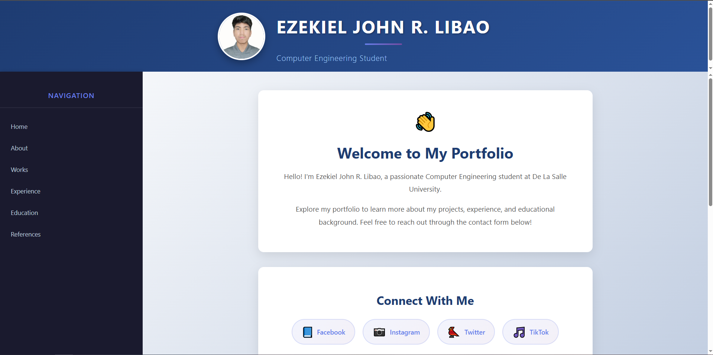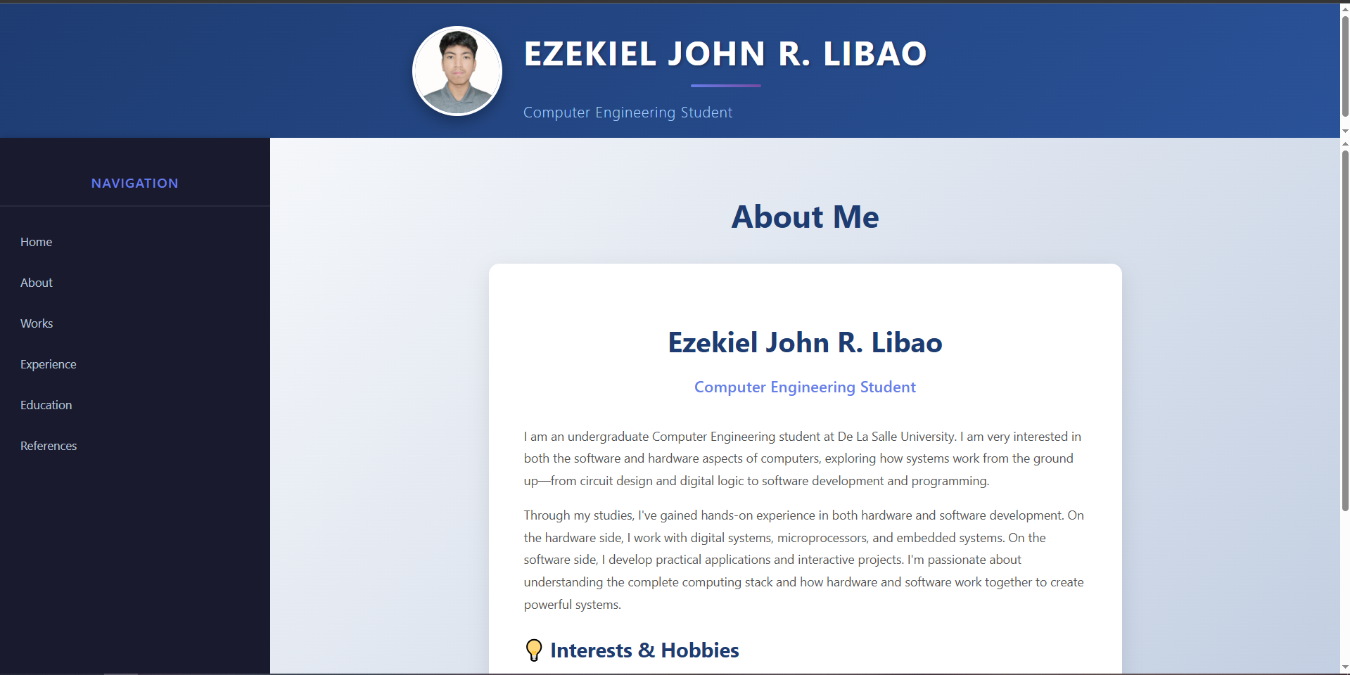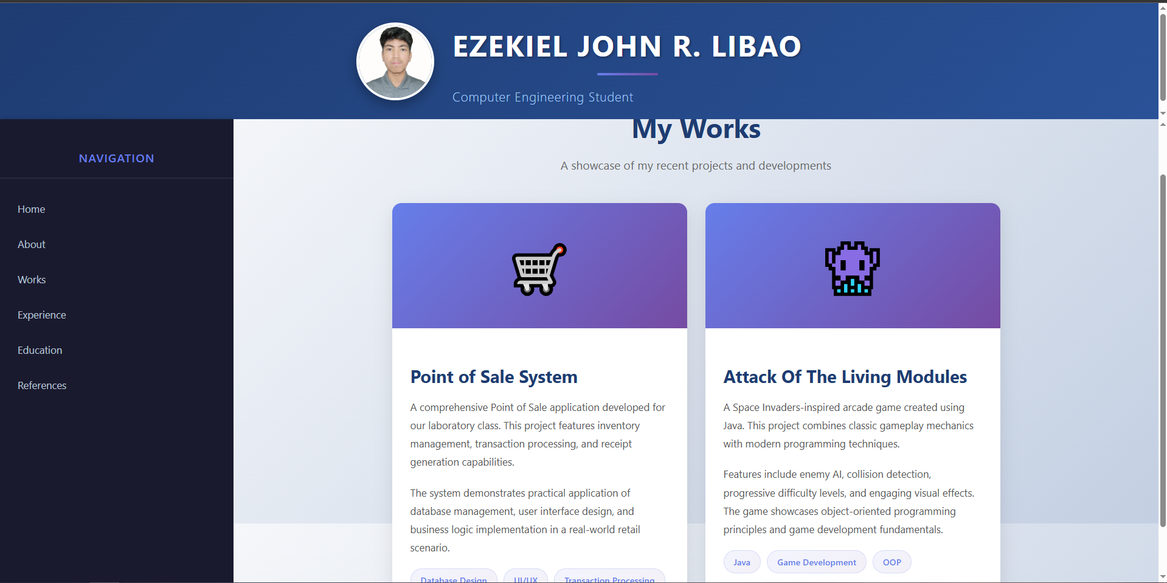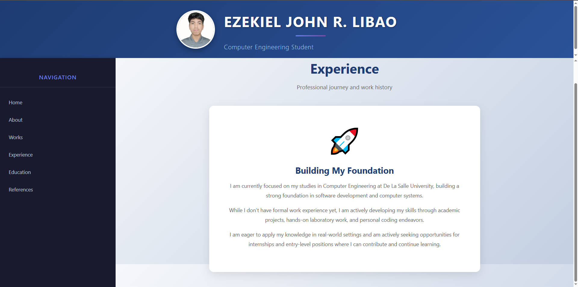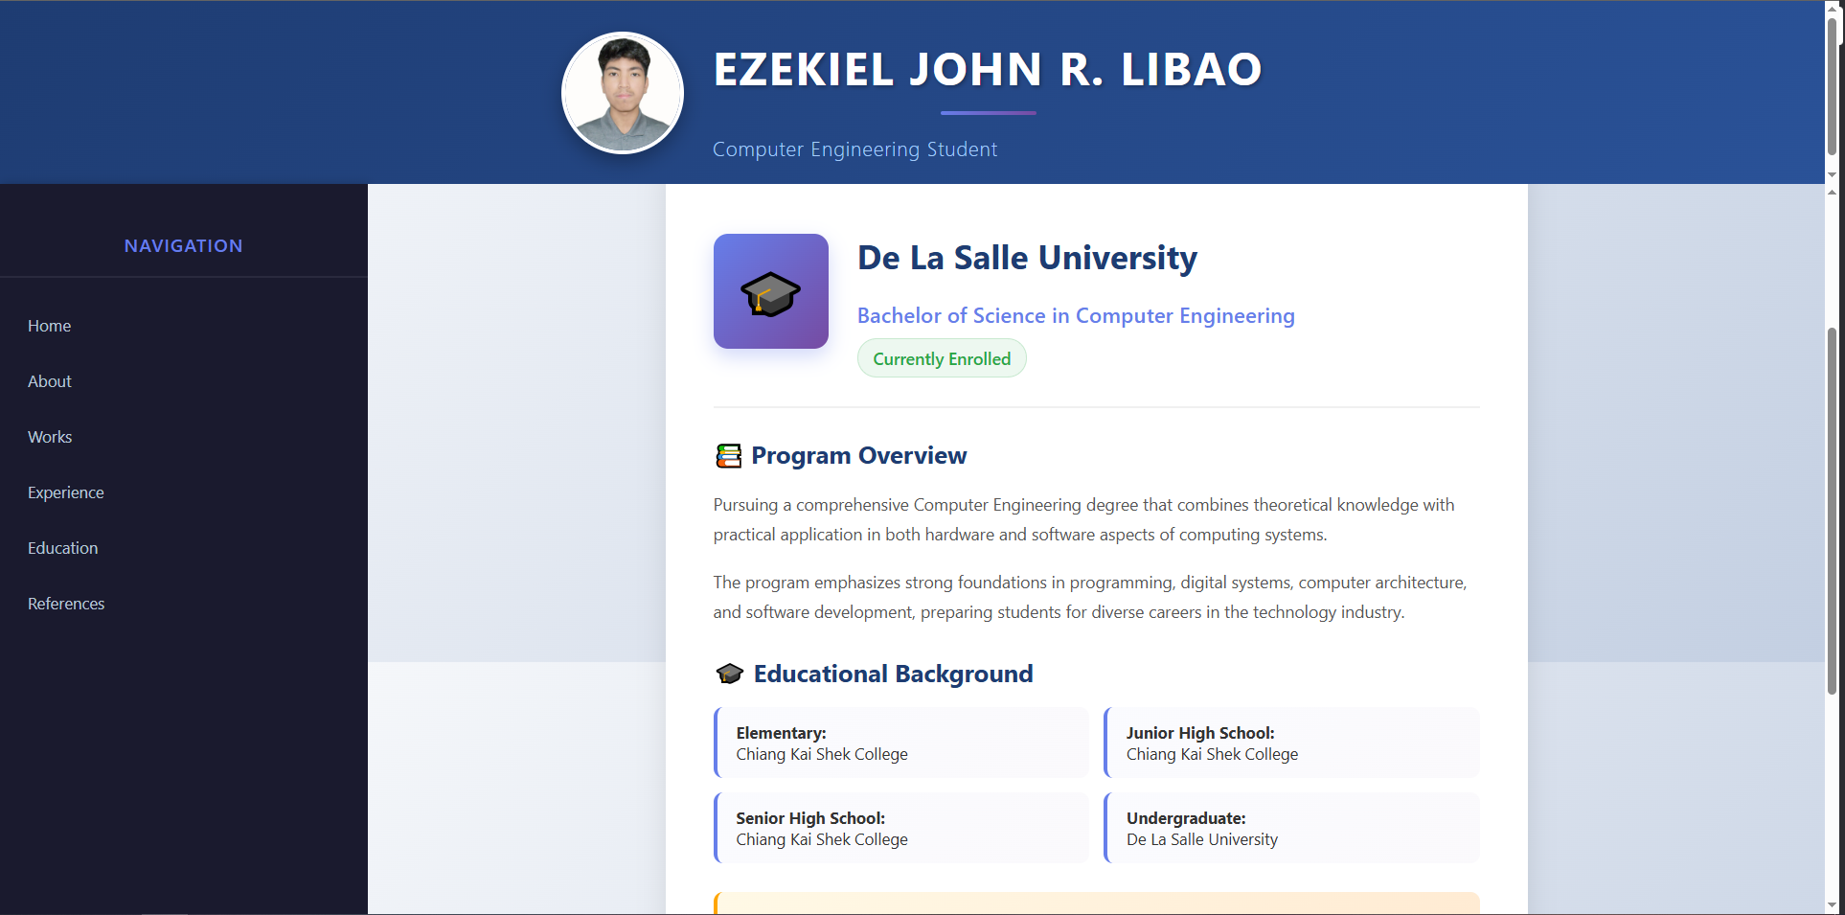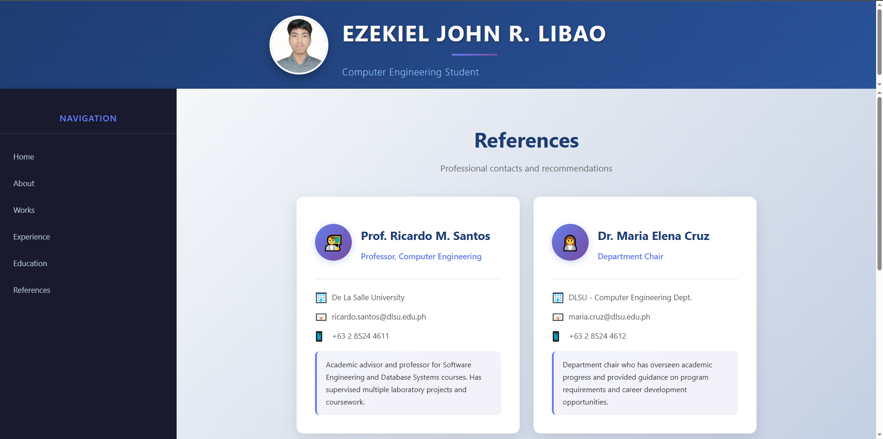

Lab Activity 3 Experimental Observation:

In this lab activity, I observed that Frames/iFrames help create a visually pleasing webpage. The header and menu sections create an efficient user experience because it no longer needs to load every time the user wants to go to a different page by clicking the links in the menu section. It is important that the “target” attribute in menu links should match the name attributes on the iframe. This ensures that the links would open properly and not inside small menu sidebar.

Conclusions:

The lab activities in this module helped me achieve all the objectives set for me in the 3 lab activities. I was able to understand the basic syntax by creating a simple web page in lab activity 1. Lab activity 2 helped me understand how to visually enhance the web page by adding images and changing the background. Lab activity 3 helped me further understand how to create a structured web page by creating a menu-driven personal portfolio web page. Through these activities, I encountered common pitfalls like not using the correct file path which caused the errors in loading the web page and navigation errors. The navigation errors gave me a challenging time because it opened links in the wrong frame. I overcame these pitfalls by carefully reviewing the file path and making sure that the “target” attributes match. For students that wish to do these activities, I recommend that you organize your folders so you can find the file path for your images easier and to open your VSCode or code editor and the web page side by side to easily view the changes that you have made.

References:

